The Japan Foundation Group Tour Program for Secondary-School Educators 2009

The Japan Foundation
Arts and Culture Dept.
Culture and Society Section
- The Purpose:
With the objectives of promoting understanding of Japan in foreign countries and understanding of foreign countries in Japan, and deepening mutual understanding between Japanese and overseas educators, this program invites secondary-school teachers in social studies, teaching staff in charge of education promoting international understanding and exchange programs, and those involved in administration on the level of secondary education. Invitees are given opportunities to receive training, conduct inspections, exchange opinions with their Japanese counterparts, and introduce their own cultures to Japan. Upon returning to their own countries, participants are expected to share their experience in Japan with students, colleagues, and communities in the form of workshops, lectures, the developing of teaching materials and curriculum, and other activities.

- The Numbers of participants and countries:
207 participants from 55 countries

- Itinerary:
- Group1: Thursday, October 1, 2009 – Wednesday, October 14, 2009 / 14 days
- Group2: Thursday, December 3, 2009 – Wednesday, December 16, 2009 / 14 days
- Group from Indonesia: Thursday, November 5, 2009 – Wednesday, November 16, 2009 / 12 days
- Group from U.S.A: Wednesday, July 1, 2009 – Friday, July 9, 2009 / 9 days
【Sample Itinerary】
Day | Itinerary |  | Lodging Place
Day | Morning | Afternoon | Lodging Place
1 | Arrival in Japan |  | Tokyo
2 | Program Orientation/ Lecture by MEXT | Lecture on Japan’s educational system | Tokyo
3 | Lecture on culture and society | Travel to Hiroshima | Hiroshima
4 | Visit historical places in Hiroshima | Travel to Kyoto | Kyoto
5 | Visit historical and cultural places in Kyoto |  | Kyoto
6 | Travel to host cities |  | Host cities
7 | Courtesy call to the Board of Education | Visit Senior High School | Same as above
8 | Visit Elementary School | Visit Junior High School | Same as above
9 | Visit Commercial/Vocational School | Visit cultural/industrial facility | Same as above
10 | Stay at host homes |  | Host homes
11 | Travel to Tokyo |  | Tokyo
12 | Optional Tour / Individual activities |  | Tokyo
13 | Visit the parliament | General summary meeting /Farewell reception | Tokyo
14 | Departure

- Lectures on education, culture, and society in Japan
A series of lectures is designed to give participants an overview of the educational system and its policy, as well as of the culture, and society of Japan.
- Visit Hiroshima and Kyoto
To develop an understanding of history and traditional culture in Japan, you will visit historical and cultural places both in Hiroshima and Kyoto (e.g., Hiroshima Peace Memorial Museum, Kinkakuji Temple, etc.).
- Host city program
The host city program aims at fostering understanding on education, culture, and society in Japan through the first-hand experience of visiting local schools, boards of education and other educational/cultural institutions, and interacting with Japanese teachers and students, and a home stay.
Groups 1 and 2 will be divided into 3 teams and each team will visit the different host cities:
- General summary meeting
After having different itineraries in their host cities, the participants will share their experiences in this summary meeting.

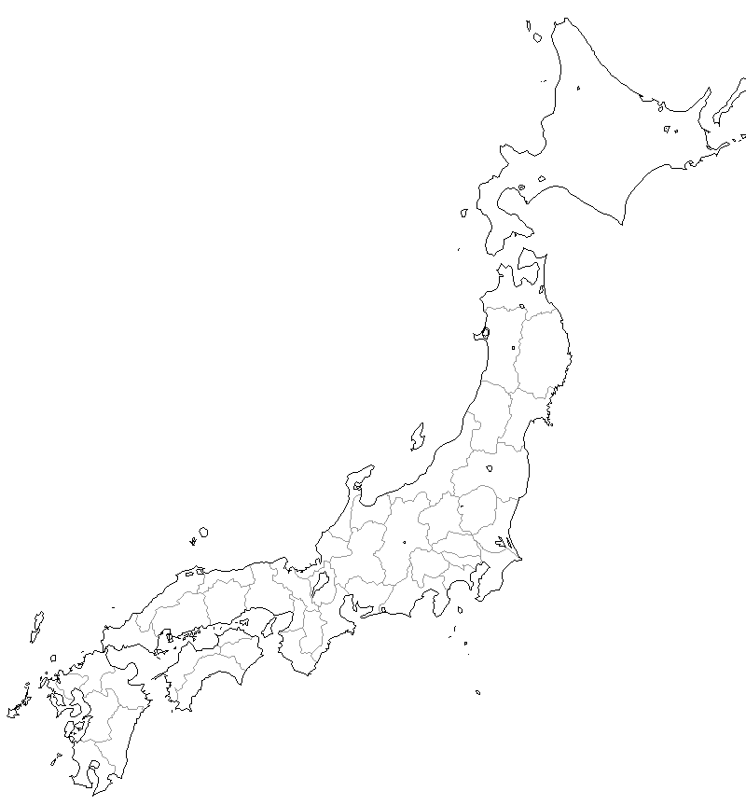
TOKYO
KYOTO
HIROSHIMA
SAITAMA
TOKYO
FUKUOKA
KYOTO
- Application and selection procedures:
  - Eligibility
- Secondary-school teachers in social studies (e.g., history, geography, politics, economics) or in charge of education promoting international understanding, having at least 5 years’ teaching experience and expecting to remain in the profession for at least a further 10 years.
- Those in charge of administration of secondary-school education (e.g., curriculum and textbook development, teacher training) who preferably have past teaching experience.
- Fair proficiency in English or those languages below. They should understand lectures on various issues and exchange opinions with other participants.
- Group 1: French, Arabic, Portuguese, Burmese
- Group 2: Spanish, Russian, Persian
- Group from Indonesia: Indonesian
*All participants are also requested to have at least Basic English proficiency in order to communicate with their host families, although they will be accompanied by interpreters throughout the itinerary.

- Participants should be in good health.
- Participants shall not have been invited to Japan by the Japan Foundation previously.
- Participants shall not have previously stayed in Japan for a long period of time (more than one month).
- Participants shall agree on the following conditions of the itinerary:
  - Take the flights arranged by the Japan Foundation (Extended stays in Japan and/or the transit places are not allowed);
  - Stay at the hotels or Japanese inns arranged by the Japan Foundation;
  - Participate in all the tour activities;
  - The spouse or children shall not be allowed to accompany the invitees, even at their own expense.
  - Application Instructions
Applicants should complete all sections of the application form.
- Personal Data: Please provide your contact information, employment information and health condition, etc.
- Professional Background: Please describe briefly your professional background, such as your experience in teaching, Japan-linked or internationally-oriented activities, and other activities related to the program objectives.
- Reasons: Please describe your interest in participating in this study tour program, describing how you would benefit from it and what you expect of it.
- Post-Program activity plan: Please state in detail your plan to share the experiences gained in this study-tour program with students, colleagues, and community.
- Questionnaire for home stay
  - Requirement for participants
Participants are required to submit a paper on their experience in Japan within 6 months after the study tour-program to the Japan Foundation.

- Expenses to be borne by the Japan Foundation
The Japan Foundation shall bear the direct costs of the Tour listed below:
  - One round-trip airfare (International airfares are limited to IATA PEX class) between Tokyo (Japan) and the international airport nearest the participant’s home residence. The reservation shall be made by the Japan Foundation and, by using the PTA method or E-ticket (Pre-Paid Ticket Advice), the ticket shall be sent to the airline office nearest to the participant’s residence;
  - Accommodation;
  - Food expenses;
  - Domestic transportation in Japan;
  - Admission fees;
  - Visa application fees, if necessary, in transit places;
  - Accommodation and food expenses, if necessary, in transit places;
  - Travel Insurance.
All participants will be covered by a group traveler’s personal illness/accident insurance policy during their stay in Japan. The type of benefits and the amount of benefits are as below:
Insurance | Type of benefit | Amount of benefit
Accident | Death benefit | \30,000,000 to the beneficiary.
Accident | Physical impediment benefit | From 3% to 100% of the death or physical impediment benefit, depending on the severity of physical impediment.
Accident | Medical expenses | Up to \2,000,000 for medical and hospitalization expenses.
Sickness | Medical expenses | Up to \2,000,000 for medical and hospitalization expenses actually incurred within 180 days of the date of an accident.
Sickness | Death benefit | \3,000,000 to the beneficiary.
* Personal baggage or other personal effects are not covered by the insurance policy.
* Expenses of a personal nature should be covered by the participants.
* The Japan Foundation does NOT cover costs that the school will have to bear due to the absence of participants from the school.

- General Information
General information on Japan is available on the following websites:
- Tourist information
  - Visit Japan Campaign http://www.visitjapan.jp/
  - Japan National Tourist Organization
http://www.jnto.go.jp/eng/location/rtg/index.html
- Education system in Japan
  - Ministry of Education, Culture, Sports, Science and Technology
http://www.mext.go.jp/english

- Contact
The Japan Foundation
Community Leaders and Youth Division, Cultural Affairs Department
Tel) +81-3-5369-6060
Fax) +81-3-5369-6036
E-mail) secschedu@jpf.go.jp

The Japan Foundation Group-Tour Program for Secondary-School Educators 2009
207 educators from 57 countries to be invited.
Thursday, Oct. 1 - Wednesday, Oct. 14 |  |  |  |  |  | Thursday, Dec. 3 - Wednesday, Dec. 16
 |  | Group 1 |  |  |  |  |  | Group 2
East Asia |  | South Korea | 3 |  |  | South-East Asia |  | Cambodia | 3
South-East Asia |  | Thailand | 3 |  |  |  |  | Brunei | 3
 |  | Philippines | 3 |  |  |  |  | Laos | 3
 |  | Vietnam | 3 |  |  | South Asia |  | Nepal | 3
 |  | Malaysia | 3 |  |  |  |  | Pakistan | 3
 |  | Myanmar | 10 |  |  | Central and South America |  | Mexico | 3
South Asia |  | India | 3 |  |  |  |  | Cuba | 3
Oceania |  | Australia | 3 |  |  |  |  | Peru | 3
North America |  | Canada | 3 |  |  | Western Europe |  | Netherlands | 3
Central and South America |  | Brazil | 3 |  |  |  |  | Austria | 3
Western Europe |  | Italy | 3 |  |  | Eastern Europe |  | Bulgaria | 3
 |  | U.K. | 3 |  |  |  |  | Ukraine | 3
 |  | Germany | 3 |  |  |  |  | Georgia | 3
 |  | France | 5 |  |  |  |  | Uzbekistan | 3
 |  | Portugal | 3 |  |  |  |  | Tajikistan | 3
Eastern Europe and Russia |  | Hungary | 3 |  |  |  |  | Rumania | 3
 |  | Russia | 3 |  |  | Middle East and Northern Africa |  | Afghanistan | 3
 |  | Azerbaijan | 3 |  |  |  |  | Iran | 10
 |  | Kazakhstan | 3 |  |  | Africa |  | Gabon | 2
 |  | Kirgiz | 3 |  |  |  |  | Cote d’Ivoire | 2
 |  | Turkmenistan | 3 |  |  |  |  | Congo | 2
Middle East |  | Egypt | 3 |  |  |  |  | Senegal | 3
 |  | Iraq | 3 |  |  |  |  | Chad | 1
 |  | Syria | 3 |  |  |  |  | Togo | 2
Africa |  | Cape Verde | 1 |  |  |  |  | Nigeria | 2
 |  | 25 countries | 82 |  |  |  |  | Burkina-Faso | 2
 |  |  |  |  |  |  |  | Mali | 2
 |  |  |  |  |  |  |  | Djibouti | 2
 |  |  |  |  |  |  |  | Seychelles | 2
 |  |  |  |  |  |  |  | South Africa | 2
 |  |  |  |  |  |  |  | 30 countries | 85
Wednesday, Jul. 1 - Thursday, Jul. 9
 | Group from U.S.A.
North America | U.S.A. |  |  | 25
Thursday, Nov. 5 - Monday, Nov.16
 | Group from Indonesia
South-East Asia | Indonesia |  |  | 15

